GSM Arena

By

Akash Sharma

Level-6

Final Project

Table of Contents

Project Proposal 3

Goals and Objectives 3

Project Scope 3

Project Specifications 3

Target Audience 3

Project Deliverables 4

Resource Requirements 4

Project Tasks and Milestones 4

Project Assumptions 5

Project Report 5

Detail Design 6

Home Page 6

Registration Page 6

Login Page 7

All Companies Admin View 7

Mobile Page Admin View 8

All Mobiles Visitor View 8

All Companies Visitor View 9

Mobile Details Page Visitor View 9

Project Testing 10

User Manual 10

Summary 10

System Configuration 10

User Access Levels 10

# 

# Project Proposal

## Goals and Objectives

The main goal or aim of the project is to implement an online web application named “GSM Arena”. The main purpose of the application is help people to find mobile devices of different companies and blog entries of mobile devices. In this application there are two types of users- admin and registered visitor. Admin has different functionalities as compare to registered visitor. Admin can add, edit, delete and check details of all blog and mobile and their companies. Admin can edit, delete and check details of the mobile reviews. Also, admin can delete and access details of the reviews and companies.

## Project Scope

The scope of this project is to implement an app named “GSM Arena” with the help of which user can find any mobile and review them. The duration of the project is 20 working days which is equals to 4 weeks.

## Project Specifications

* Admin login/logout
* Add, edit, delete and check details of mobile by admin.
* Admin can delete, edit and check mobile companies.
* Admin can delete and check blog for Application.
* Admin can register new admins.
* Registered Visitor can login/logout.
* New Visitor can register.
* Visitor can review the Mobile Details.

## Target Audience

The target audience for this project is the food lover people who would like to enhance knowledge of Mobile devices and their latest information. The age can go from 18 plus to 100 plus.

## Project Deliverables

The deliverables of the project are:

|  |  |
| --- | --- |
| **Deliverable** | **Description** |
| Final Report | This will be the final report of the project. |
| Coding | The executable code of the project will go under this. |
| Documentation | This portrays the documentation of the project. |
| Testing | All the test details will be covered in this part. |

## Resource Requirements

* Windows Operating System.
* Microsoft word for documentation.
* Asp.net MVC Framework
* 64-bit Processor and 4 GB or more RAM
* Identity framework- ASP

## Project Tasks and Milestones

|  |  |  |  |  |
| --- | --- | --- | --- | --- |
| **Tasks** | **Week-1** | **Week-2** | **Week-3** | **Week-4** |
| Brainstorming and analysis |  |  |  |  |
| Planning and initial meeting Project Proposal document. |  |  |  |  |
| Database Design and UI Design |  |  |  |  |
| Identity framework implementation |  |  |  |  |
| Coding for admin and reporter |  |  |  |  |
| Testing |  |  |  |  |
| Final Documentation and closing |  |  |  |  |

## Project Assumptions

Following are the assumption made while implementing the project:

* One admin and registered visitor will be registered by default.
* Application will be free and open source.

# Project Report

#### Functional and Non-Functional

|  |  |
| --- | --- |
| Users | Functional |
| Admin | * Login/logout * Register new admins * Admin can add, edit, delete, check details for companies. * Admin can edit, delete and check details for mobile. * Admin can delete and check details for the blog entries. |
| Customer | * Can view details of companies, mobile and blog entries. * Can review the mobile * New customers can register for free. * Login using valid credentials |
|  | Non- Functional |
|  | * High speed * Fast Loading time * High performance and security * All browsers compatibility. |

## Detail Design

### Home Page

The main landing page of the application. On navigation bar options are- Home, All Companies, All Mobile, Blogs, Register, Login.

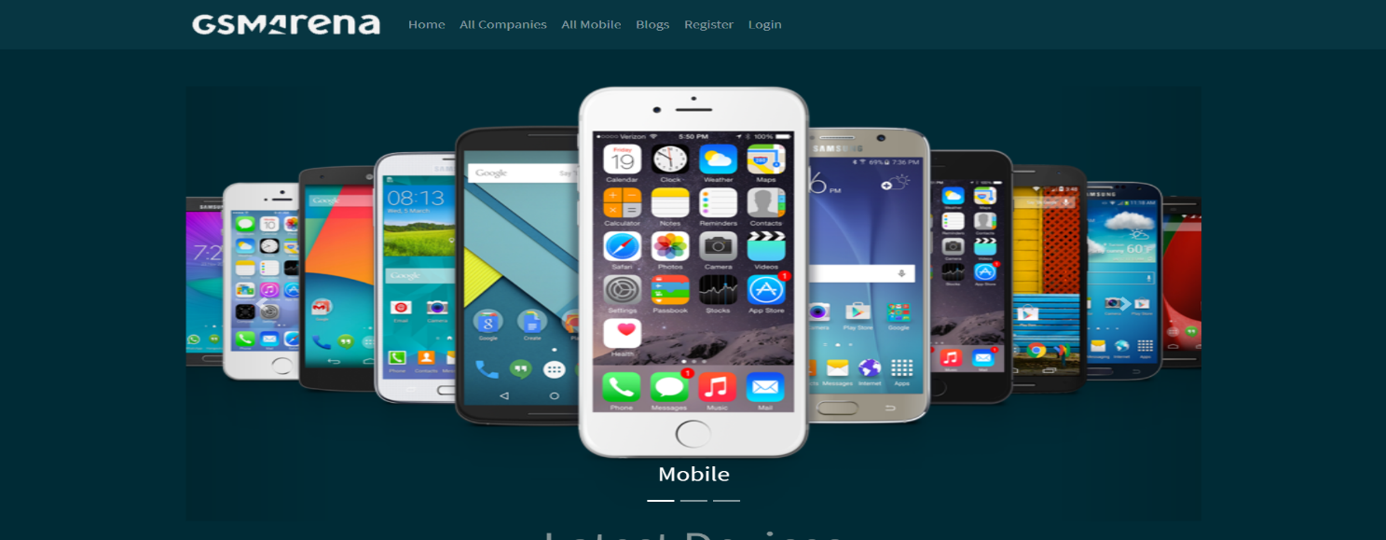

### Registration Page

With the help of this page, new registered visitor can sign up for the app

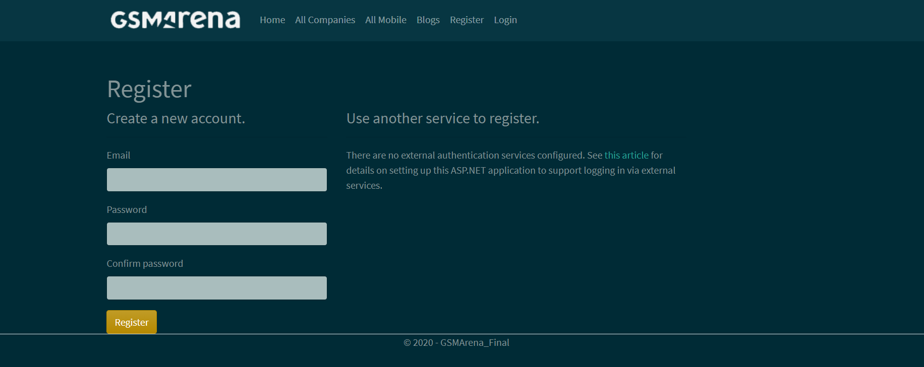

### Login Page

With the help of this page, registered visitor and admin can login to the application using their valid credentials.

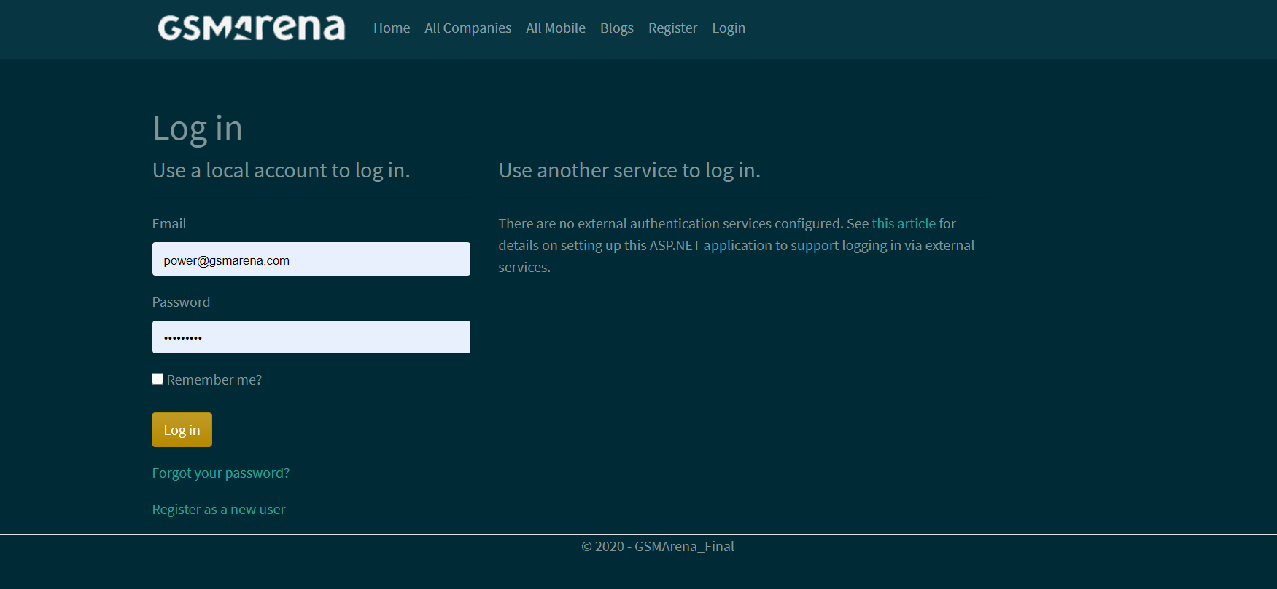

### All Companies Admin View

This page highlights all the Companies available on the application. Admin can add new Company, edit, delete and check details of the existing ones.

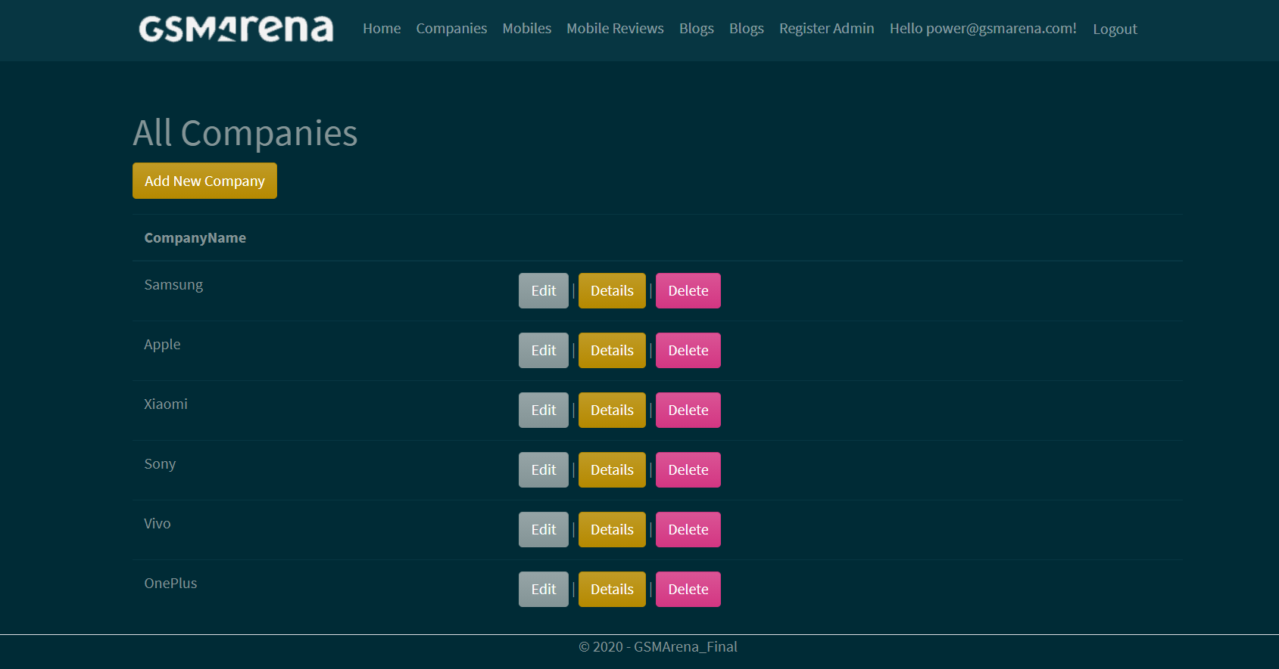

### Mobile Page Admin View

With the help of this page admin can manage the mobiles by editing, deleting and checking their details.

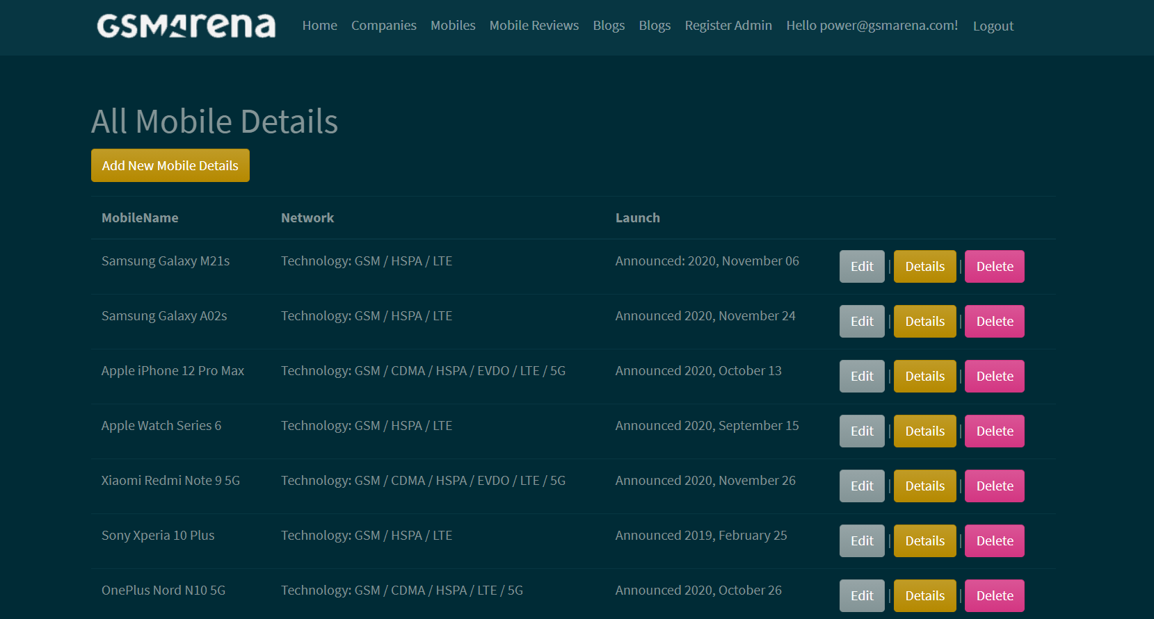

### Mobile Page Visitor View

With the help of this page Visitor can view Mobile details.

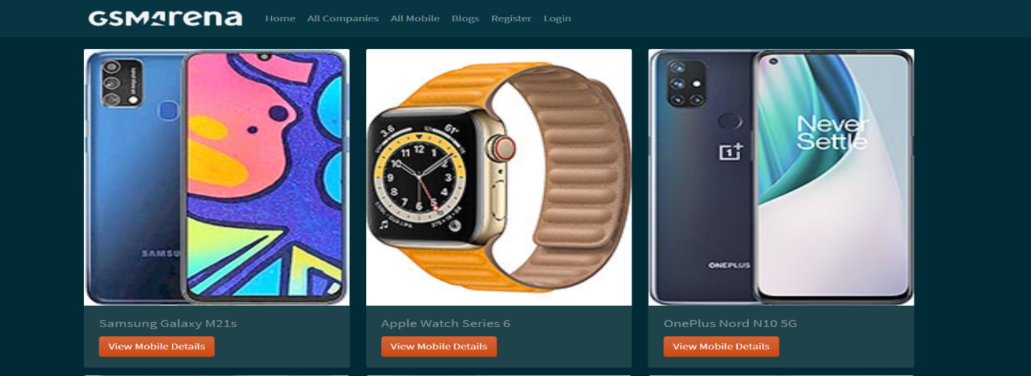

### All Companies Visitor View

With the help of this page visitor can check the details of the companies and their mobile devices.

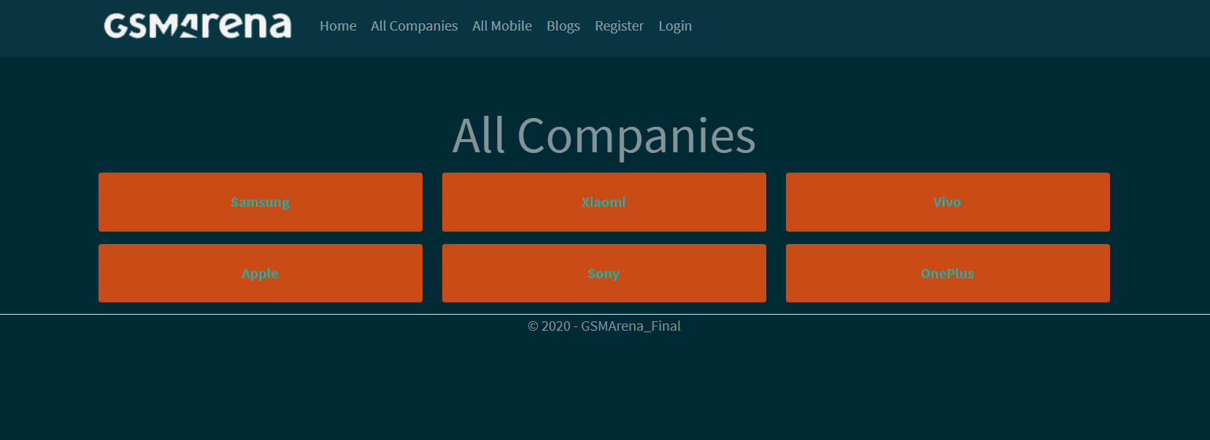

### Mobile Details Page Customer View

This page shows the Mobile details and pricing of the recipes.

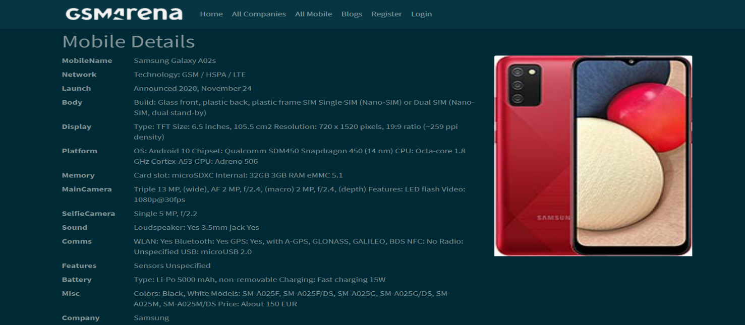

## Project Testing

The testing file for usability testing is attached as [usability test.xlsx](usability%20test.xlsx)

# User Manual

The main purpose of the application GSM Arena is to help people to find mobile of their choice based upon other visitor review. In this application there are two types of users- admin and registered user or visitor customer. Admin has different functionalities as compare to customers. Admin can add, edit, delete and check details of companies, blog entries. Admin can edit, delete and check details of the companies, mobile and blog entries. Also, admin can delete, and access details of the review made by the visitor.

## Summary

### System Configuration

This app will be useful to for distributing mobile information in presentable format.

### User Access Levels

Only registered users can access the features of this application.

* **Admin:** Admin has full access of the app can register new admins.
* **Registered Visitor:** New visitor can register and existing can login using their own credentials. They have limited access.